**EXECUTIVE SUMMARY**

**PURPOSE AND SCOPE:**

The purpose and scope of this assignment are to design and implement a robust server-client communication system utilizing two distinct transport layer protocols: TCP (Transmission Control Protocol) and UDP (User Datagram Protocol). The primary objective is to create a seamless channel for exchanging messages between a server and a client while highlighting the unique characteristics of each protocol.

In the case of TCP, a connection-oriented approach is employed, emphasizing reliability and data integrity. Input and Output buffers are leveraged to facilitate message transmission and reception in the Java programming language. A pivotal aspect of TCP implementation is the execution of a two-way handshake between the client and server, ensuring that both sides are prepared for communication. Additionally, rigorous validation mechanisms are integrated to scrutinize incoming client requests, guaranteeing that they conform to protocol standards. In instances where the server encounters an inability to execute a particular operation, it promptly responds with appropriate error messages, maintaining a transparent and informative client-server interaction.

In contrast, UDP is harnessed to harness the benefits of connectionless, low-latency communication. Datagram packets are utilized to encapsulate essential message information, including the message itself, its length, InetAddress (representing the client's IP address), and the port number. This approach favors speed and agility, making it suitable for applications prioritizing swift data transmission over absolute reliability. Crucially, the project incorporates robust logging mechanisms, timestamping and persisting all communication, and system interactions to log files. This logging framework serves as a valuable tool for monitoring and troubleshooting the communication process, enhancing system transparency and facilitating debugging.

To enhance client resilience, a timeout mechanism is implemented, allowing the client to handle unresponsive servers gracefully. If a response is not received within a defined timeframe, the client can take appropriate actions, such as retransmitting requests or managing timeouts effectively.

**TECHNICAL OVERVIEW:**

In the context of this assignment, the utilization of both UDP (User Datagram Protocol) and TCP (Transmission Control Protocol) transport layer protocols offered a great learning experience. Implementing these protocols exposed us to the intricacies of network communication, emphasizing the trade-offs between reliability and speed. With TCP, the emphasis was on creating a reliable and ordered connection, learning how to perform a two-way handshake, and ensuring data integrity. Meanwhile, UDP encouraged us to embrace a connectionless, low-latency approach, appreciating its speed advantages while managing the absence of built-in reliability. The assignment encouraged the practice of abstraction and code refactoring. By abstracting common functionalities into interfaces and reusable classes, we were able to write more maintainable and modular code. This approach facilitated code reuse and allowed for easier testing and debugging. Additionally, the process of code refactoring helped identify and eliminate redundancy, resulting in cleaner and more efficient implementations. Below is my code structure.

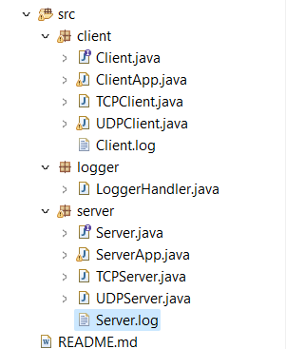

The integration of a logger for logging communication activities was a valuable addition to the project. It demonstrated the importance of maintaining a comprehensive record of communication between the client and server. Logging not only facilitated debugging but also provided insights into the sequence of events during execution. It allowed us to monitor the flow of data, validate protocol adherence, and pinpoint issues promptly.

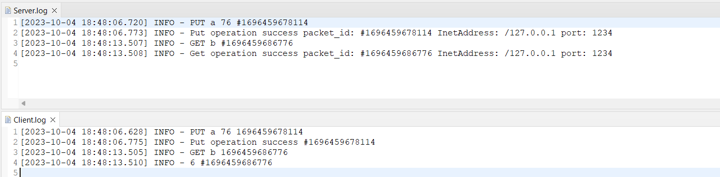

However, the single-threaded server-client implementation processes one client request sequentially, leading to limited concurrency and sluggish response times for multiple clients. This approach's blocking nature prevents simultaneous handling of requests, impacting overall server responsiveness. Moreover, it results in inefficient resource utilization as the server idles while waiting for client requests, potentially underutilizing system resources. These limitations can be overcome using multi-threading. Multi-threading assigns each client connection to its thread, enabling concurrent service for multiple clients and simultaneous request processing. This approach enhances concurrency, leading to faster response times and optimal resource utilization. Multi-threading ensures non-blocking behavior, allowing clients to interact independently, even when one client's operation is ongoing. It also offers scalability by dynamically creating and managing threads, making the server efficient in handling a large number of concurrent connections.

**USE CASE:**

Home Automation Control System:

Server: The server acts as a central control hub, managing smart devices and sensors in a home. It processes user commands and monitors sensor data for devices like lights, thermostats, security cameras, and appliances.

Client: The client is a mobile or web app installed on the homeowner's device. It serves as the control interface.

Scenario: Homeowners use the app to remotely control home devices. The client sends commands to the server via sockets, which then controls the devices accordingly.

Benefits: It provides remote convenience, centralized control, and customization. This architecture simplifies smart home management via socket-based communication.